Project:2
Mini Penetration Testing Report

Used (DVWA and bWAPP)
The purpose of this assessment was to understand how common web vulnerabilities appear, how they can be exploited, and how security controls differ across applications.

Objective
The objectives of this project were:
- To set up DVWA locally on Kali Linux
- To deploy bWAPP on a separate virtual machine
- To access bWAPP remotely using its IP address
- To perform reconnaissance, scanning, and exploitation
- To compare vulnerabilities found in both applications
- To document findings in a professional penetration testing report

Scope of Testing
The scope of this penetration test included:
- DVWA running locally on Kali Linux
- bWAPP running on a virtual machine accessible via IP
- Web application level testing only
All testing was conducted in a controlled lab environment.

Lab Environment
- Attacker Machine: Kali Linux
- DVWA: Installed and running locally in Kali browser
- bWAPP: Installed on a separate virtual machine
- Network: Virtual network (Host-only / NAT)
- Access Method: Browser-based testing using IP address

Tools Used
- Kali Linux
- DVWA
- bWAPP Virtual Machine
- Nmap
- DIRB
- Nikto
- Firefox Browser

Methodology
The penetration testing process followed these phases:
- Reconnaissance
- Scanning and enumeration
- Vulnerability identification
- Exploitation
- Analysis and reporting

Reconnaissance and Scanning

Nmap Scanning for bWAPP VM (IP :- 10.0.2.15)
Nmap was used to identify open ports and running services on the bWAPP virtual machine.
Command used: nmap -sV 10.0.2.15
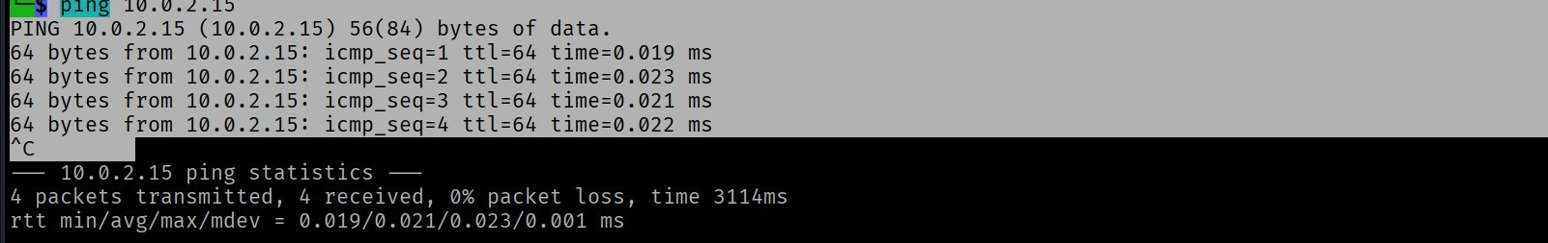
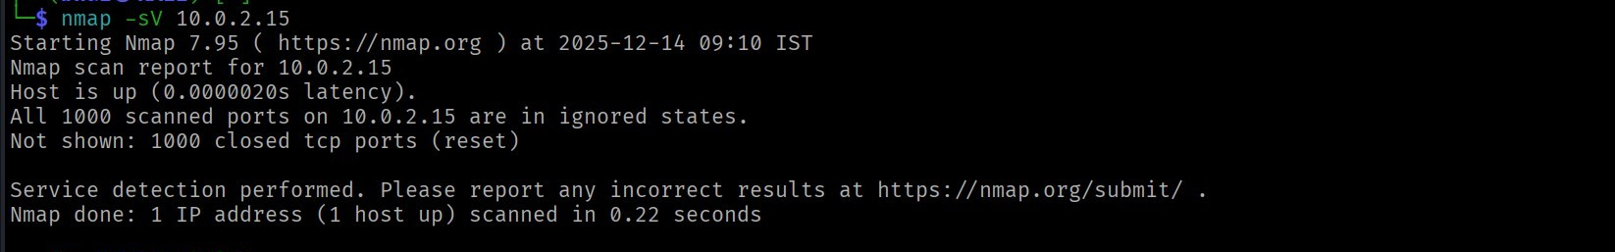
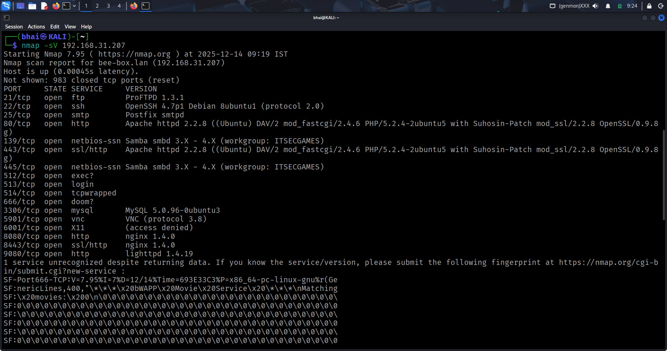
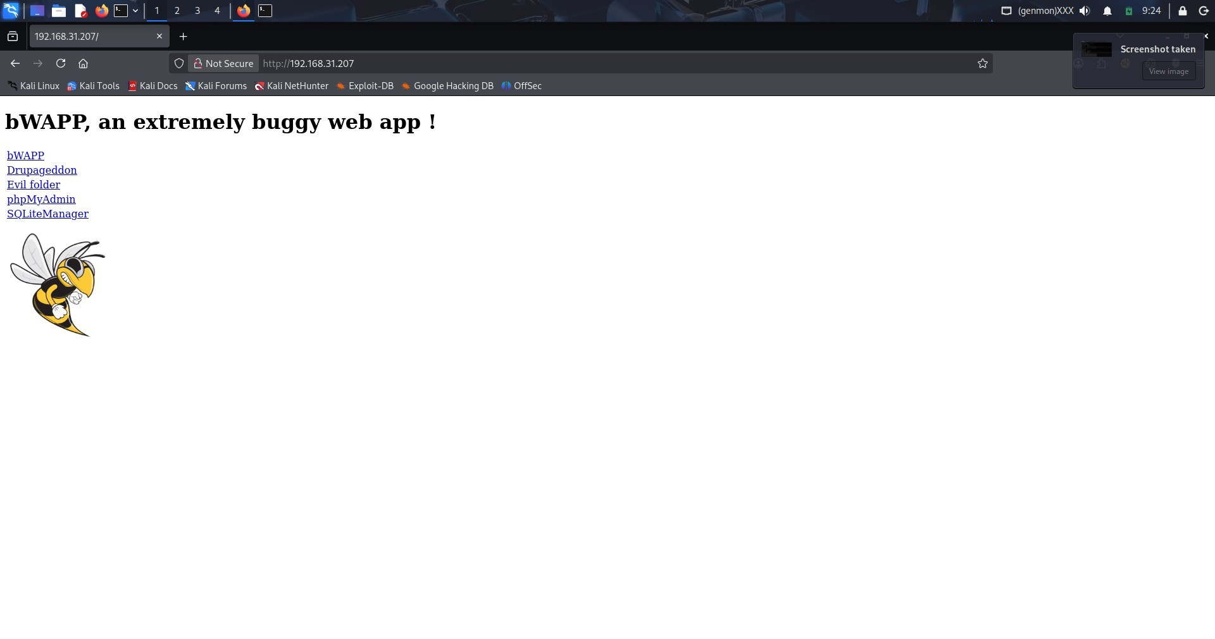
Observation:
- The target host was reachable and responded to network probes
- Multiple open ports were discovered on the system
- FTP, SSH, and SMTP services were exposed, increasing remote access risk
- HTTP and HTTPS services were running on ports 80 and 443
- Additional web services were detected on ports 8080, 8443, and 9080
- SMB services were enabled on ports 139 and 445
- MySQL database service was exposed on port 3306
- VNC remote access service was found running on port 5901
- Several services were running outdated software versions
- The large number of exposed services indicated poor system hardening and an expanded attack surface

Directory Enumeration using DIRB
DIRB was used to discover hidden directories and endpoints.
Command used for DVWA:
dirb http://127.0.0.1:42001
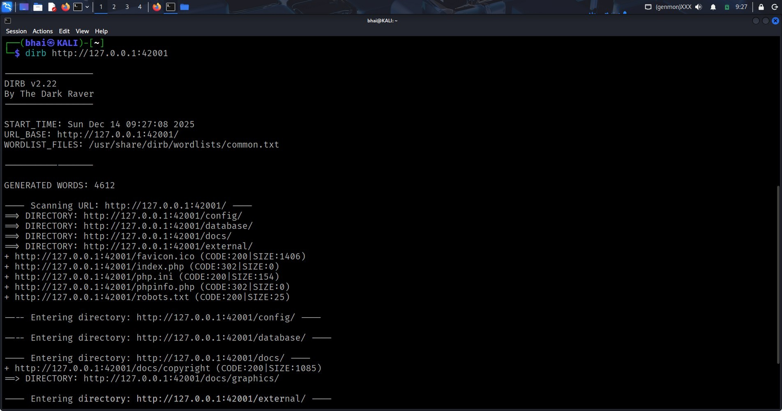
Command used for bWAPP: dirb http://192.168.31.207/
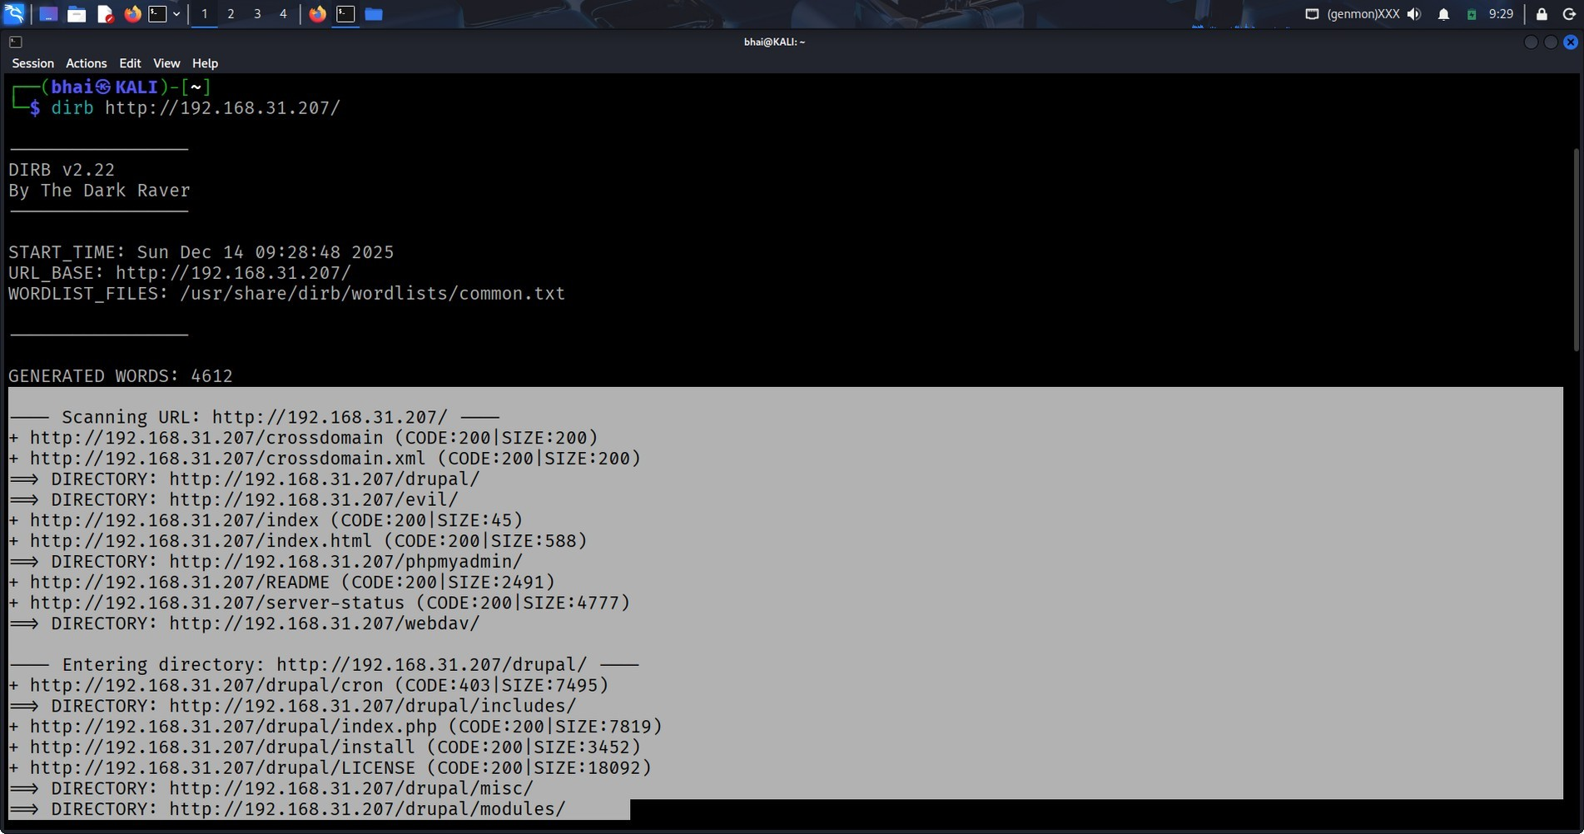
Observation:
- DVWA exposed multiple vulnerable endpoints
- bWAPP revealed several testable paths

Web Server Scanning using Nikto
Nikto was used to identify server-level security issues.
Command used for DVWA:
nikto -h http://127.0.0.1:42001
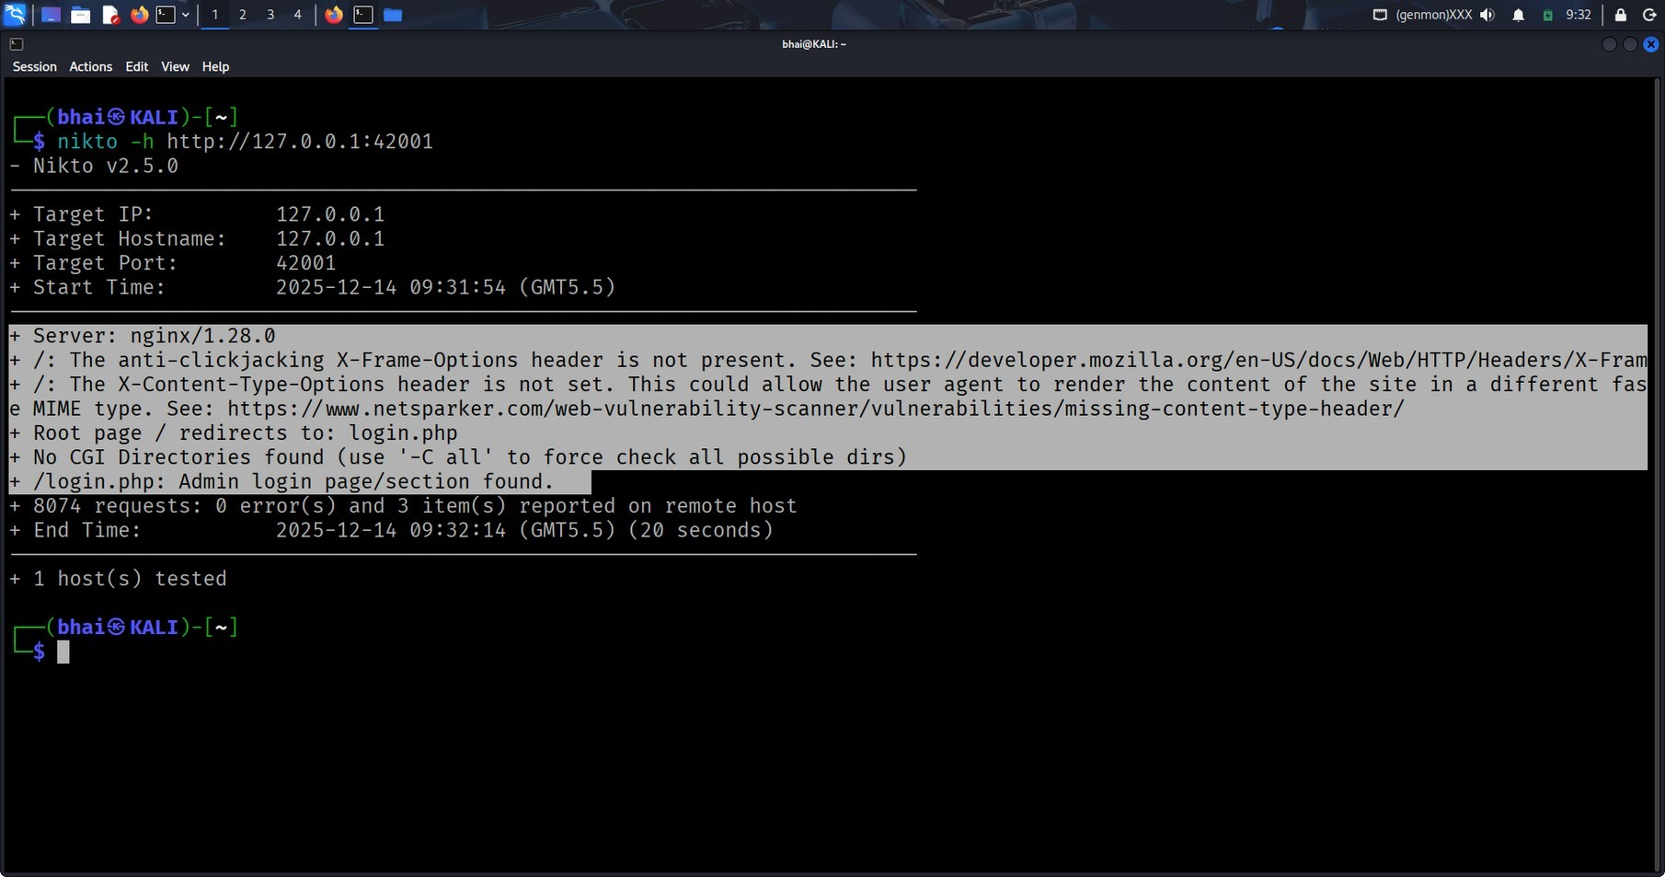
Command used for bWAPP: nikto -h http://192.168.31.207/
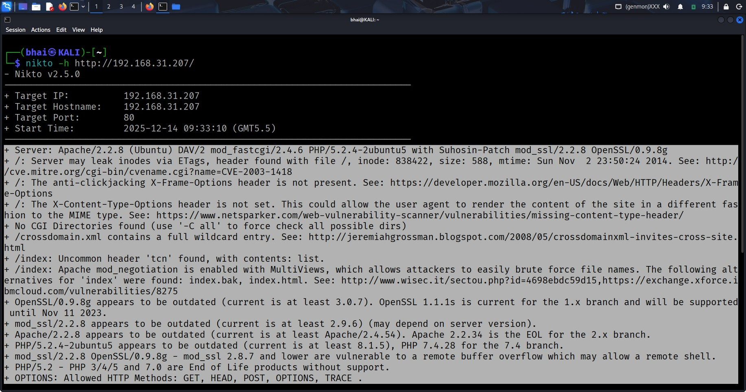
Observation:
- Missing security headers
- Outdated server configurations
- Information disclosure issues

Vulnerability Findings in DVWA

SQL Injection
SQL Injection was tested on DVWA input fields.
Payload used:
' OR '1'='1
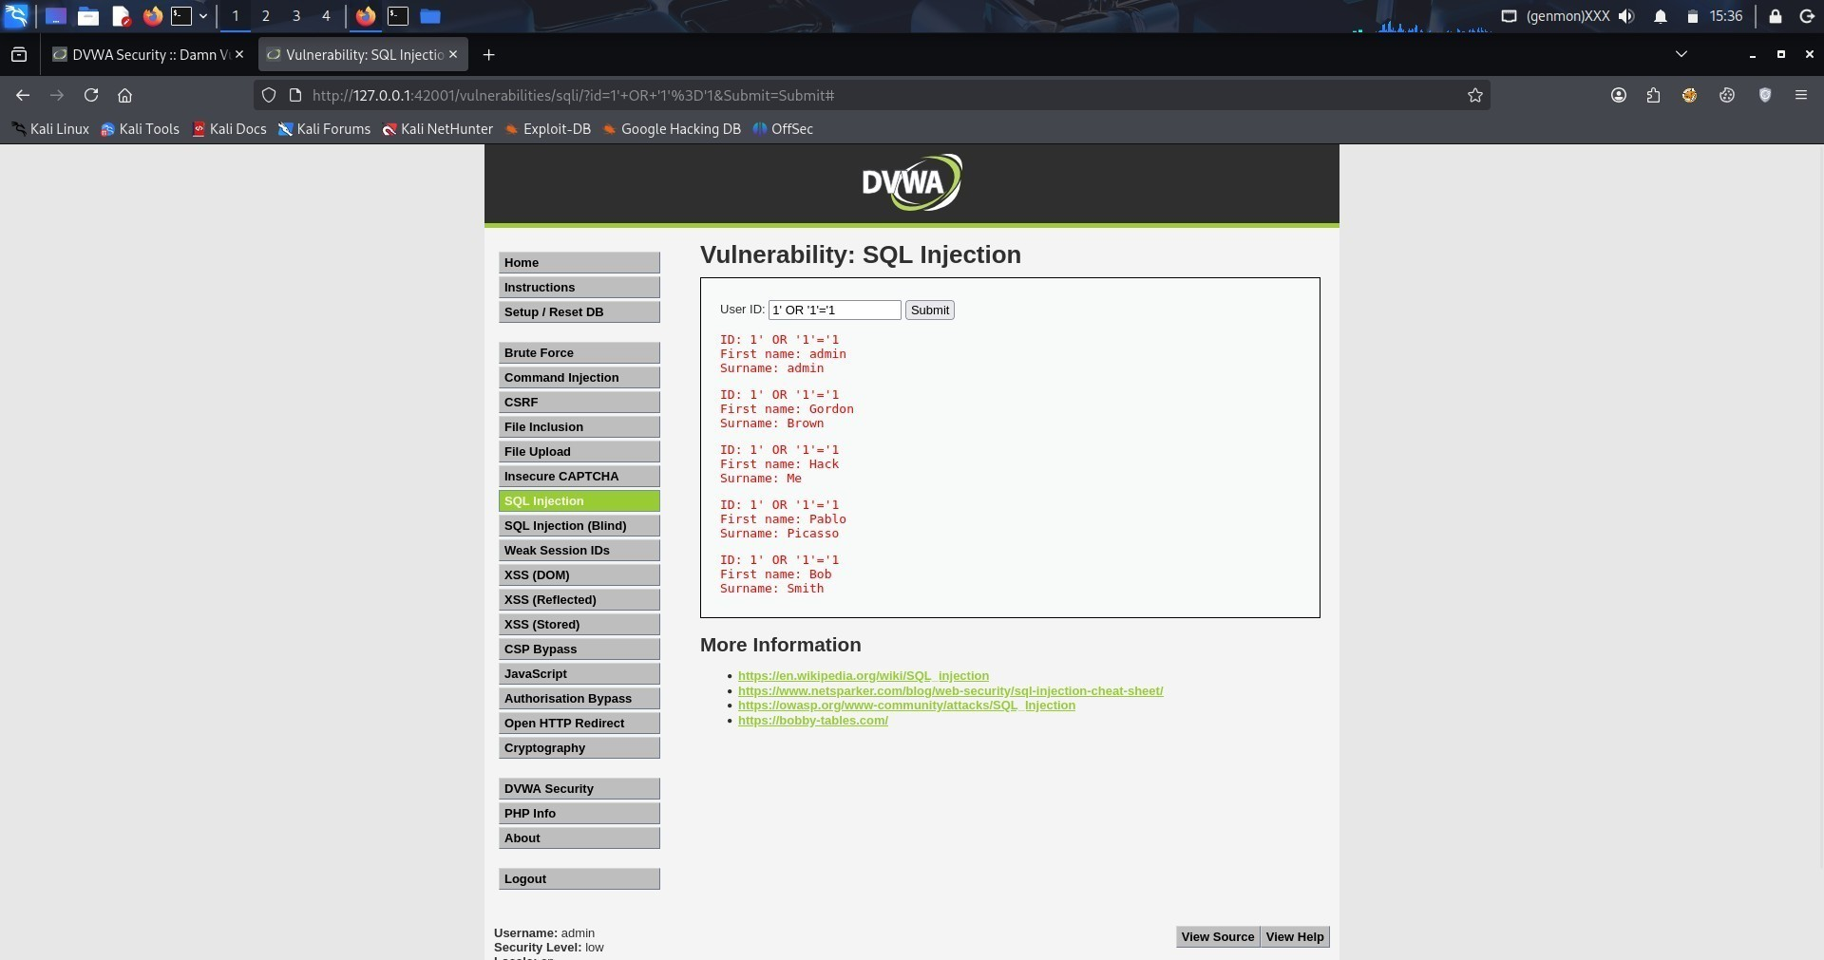
Result:
•
Authentication bypass was successful
•
Database records were exposed
Cause:
•
No input validation
•
SQL queries constructed dynamically
Cross-Site Scripting
Reflected XSS was tested on DVWA input fields.
Payload used:
<
script>alert('XSS')</script
>
Result:
- Browser alert appeared Cause:
- Output rendered without encoding

Cross-Site Scripting
XSS was tested using input fields in dvwa.
Payload used:
<img src=x onerror=alert('XSS')>
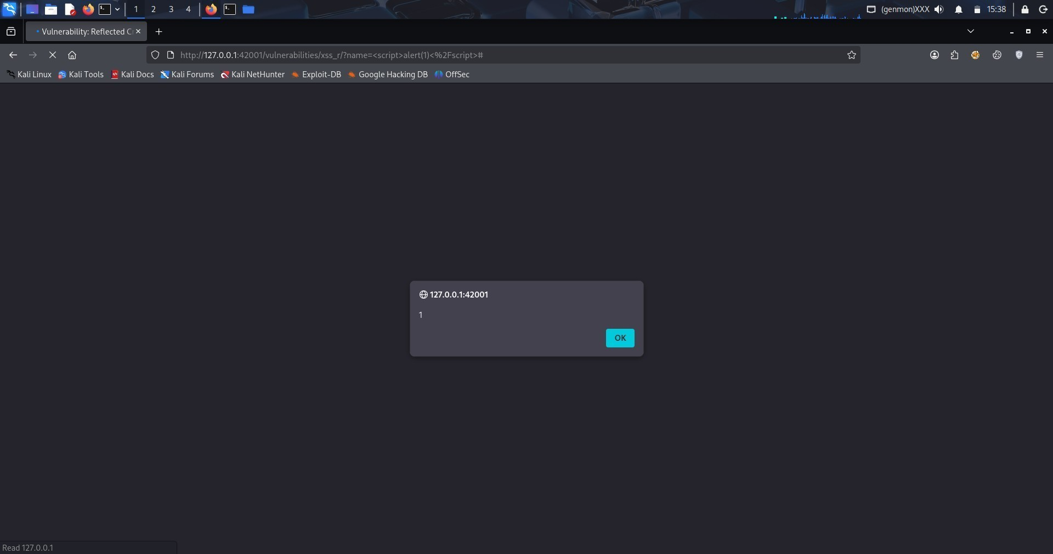
Result:
- Script executed in browser Cause:
- Missing input filtering and output encoding

Comparison of DVWA and bWAPP
DVWA is designed to demonstrate common web vulnerabilities at different security levels, making it easier to understand how insecure coding leads to exploitation and how defenses gradually improve. It provides a structured learning environment where vulnerabilities such as SQL Injection and Cross-Site Scripting can be clearly observed and tested.
bWAPP, on the other hand, offers a broader collection of vulnerabilities in a more realistic deployment environment. Running bWAPP on a separate virtual machine helped simulate realworld penetration testing scenarios where the attacker and target reside on different systems. While DVWA supported direct manual exploitation, bWAPP was primarily assessed through reconnaissance, service enumeration, and configuration analysis.

Executive Summary
This mini penetration testing project assessed two intentionally vulnerable web applications, DVWA and bWAPP, in a controlled lab environment. Critical web vulnerabilities such as SQL Injection and Cross-Site Scripting were successfully validated in DVWA, highlighting the risks of insecure input handling.
In the case of bWAPP, multiple high-risk security issues were identified through scanning and reconnaissance, including excessive service exposure and outdated software components. The assessment emphasizes the importance of secure coding practices, system hardening, and regular security testing to reduce attack surfaces.

Technical Findings
- SQL Injection vulnerabilities successfully identified and exploited in DVWA
- Cross-Site Scripting vulnerabilities validated in DVWA
- Multiple unnecessary network services exposed on the bWAPP system
- Outdated versions of web server and supporting services detected
- Missing HTTP security headers
- Weak system hardening and insufficient service minimization

Remediation Recommendations
- Use prepared statements and parameterized queries for database access
- Validate and sanitize all user-supplied input
- Apply proper output encoding to prevent XSS
- Implement secure authentication and session management
- Disable unnecessary services and close unused ports
- Regularly update and patch software components
- Follow OWASP Top 10 security best practices

Conclusion
This project provided practical exposure to penetration testing techniques in a realistic lab environment. By assessing applications deployed on different systems, the project strengthened understanding of both web application vulnerabilities and network-based attack surfaces.
The combination of manual testing and automated scanning improved technical skills, analytical thinking, and professional security reporting capabilities.

Learning Outcomes
- Understanding of real-world penetration testing environments
- Hands-on experience with DVWA and bWAPP assessment
- Improved vulnerability identification and analysis skills
- Strong understanding of security testing tools and methodologies
- Experience in writing professional penetration testing reports

